**22-07-2024 JAVA Codes (Theory)**

Program 1:

import java.util.*;

class test

{

public static void main(String[] args)

{

    String firstName= "John";

    String lastName="Doe";

    System.out.println(firstName.concat(lastName));

}

}

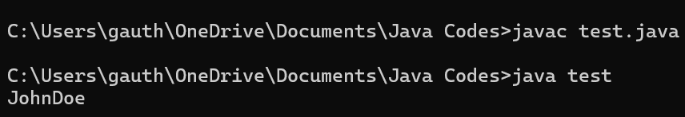

Program 2:

import java.util.*;

class test

{

public static void main(String[] args)

{

    String x="10";

    int y=20;

    String z=x+y;

    System.out.println(z);

}

}

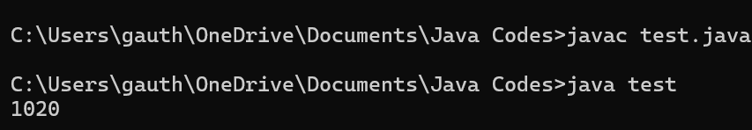

Program 3:

import java.util.*;

class test

{

public static void main(String[] args)

{

    String txt= "We are the so-called \"Vikings\" from the north.";

    System.out.println(txt);

}

}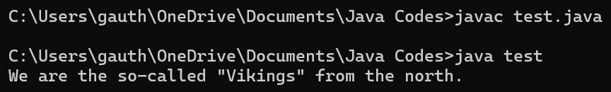

Program 4:

import java.util.*;

class test

{

public static void main(String[] args)

{

    System.out.println(Math.max(5,10));

}

}

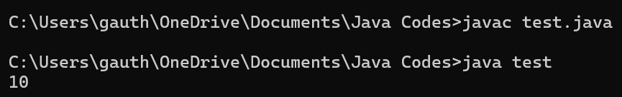

Program 5:

import java.util.*;

class test

{

public static void main(String[] args)

{

    System.out.println(Math.min(5,10));

}

}

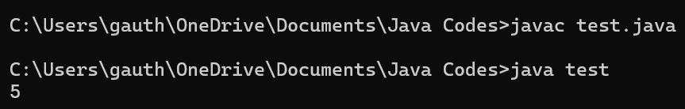

Program 6:

import java.util.*;

class test

{

public static void main(String[] args)

{

    System.out.println(Math.sqrt(25));

}

}

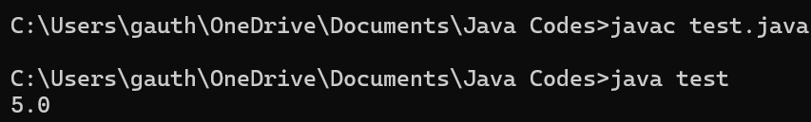

Program 7:

import java.util.*;

class test

{

public static void main(String[] args)

{

    System.out.println(Math.abs(-33));

}

}

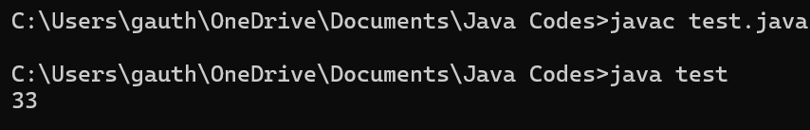

Program 8:

import java.util.*;

class test

{

public static void main(String[] args)

{

    System.out.println(Math.random()); /* only from 0.0 (inc) to 1.0 (exc) and cannot be specified */

}

}

